Article published in
Advances in Engineering Software, Vol. 85, pp 1-11, 2015

A simple and compact Python code for complex 3D topology optimization

Zhi Hao Zuo¹, Yi Min Xie^{1*}

¹Centre for Innovative Structures and Materials, School of Civil, Environmental and Chemical Engineering, RMIT University, GPO Box 2476, Melbourne 3001, Australia
*Corresponding author. Tel: +61 3 99253655; Fax: +61 3 96390138.
Email address: mike.xie@rmit.edu.au (Y.M. Xie).

Abstract

This paper presents a 100-line Python code for general 3D topology optimization. The code adopts the Abaqus Scripting Interface that provides convenient access to advanced finite element analysis (FEA). It is developed for the compliance minimization with a volume constraint using the Bi-directional Evolutionary Structural Optimization (BESO) method. The source code is composed of a main program controlling the iterative procedure and five independent functions realising input model preparation, FEA, mesh-independent filter and BESO algorithm. The code reads the initial design from a model database (.cae file) that can be of arbitrary 3D geometries generated in Abaqus/CAE or converted from various widely used CAD modelling packages. This well-structured code can be conveniently extended to various other topology optimization problems. As examples of easy modifications to the code, extensions to multiple load cases and nonlinearities are presented. This code is intended for educational purposes and would be useful for researchers and students in the topology optimization field. With further extensions, the code could solve sophisticated 3D conceptual design problems in structural engineering, mechanical engineering and architecture practice. The complete code is given in the appendix section and can also be downloaded from the website: www.rmit.edu.au/research/cism/.

Keywords: Topology optimization, BESO, Python code, Abaqus, NumPy
1 Introduction
Structural topology optimization is a topic concerning the best locations for cavities in a structure design domain. This topic has been intensively investigated in the past three decades. During this time, several educational articles were published aimed at introducing fundamentals of various algorithms by presenting computer program implementations, such as the Matlab codes by Sigmund (2001) for the Solid Isotropic Material with Penalization (SIMP) method (Bendsøe 1989; Zhou and Rozvany 1991) and Challis (2010) for the level-set method (Osher and Sethian 1988; Wang et al. 2003). Also an 88-line Matlab code was developed by Andreassen et al. (2011) as an extension to Sigmund’s 99-line Matlab code with improved efficiency. These works demonstrated basic 2D compliance minimization based on a rectangular design domain discretized into linear 4-noded elements and served the educational purposes well. Huang and Xie (2010a) also published a Matlab code for 2D compliance minimization using the Bi-directional Evolutionary Structural Optimization (BESO) method (Xie and Huang 2007a, 2010b). Recently Liu and Tovar (2014) presented a Matlab implementation using a modified SIMP model for 3D topology optimization for linear structures with regular 8-noded elements. Inspired by these works, this paper presents a Python code for 3D topology optimization using the BESO method. The Python code is developed based on the Abaqus environment that provides a broad range of linear/nonlinear static/dynamic FEA capacities and meshing techniques. The code is intended for engineering education and can be extended to practical applications as well. Selected extensions are presented in the paper to enhance computational efficiency and to consider multiple load cases and geometrical nonlinearity. All the Python source codes for the basic implementation together with the selected extensions are given in the appendix section.
The BESO method is developed from the Evolutionary Structural Optimization (ESO) method (Xie and Steven 1993; Xie and Steven 1997). The original ESO is a heuristic method based on removing lowly-stressed materials. Through years of development, the current form of BESO has become a gradient-based mathematical optimization method with convergent and mesh-independent algorithms (Huang and Xie 2007a). Recent applications of BESO have addressed a range of macro structural optimization problems including compliance minimization (Huang and Xie 2009), frequency maximization (Huang et al. 2010), displacement constraints (Huang and Xie 2010c; Zuo et al. 2012), as well as inverse homogenization (Sigmund 1995) problems such as material moduli maximization (Yang et al. 2013; Radman et al. 2014) and concurrent designs (Huang et al. 2013; Zuo et al. 2013).
The Python code provided in this paper is based on the “soft-kill” BESO scheme (Huang and Xie 2009). Like the SIMP method, BESO is based Finite Element Analysis (FEA) and treats the relative densities of elements as the design variables. For a discrete 0-1 design problem, a design variable takes values of either 1.0 indicating the presence of the element (solid status), or a prescribed small number such as 0.001 (usually denoted as x_{min)}, indicating the absence of the element (void status). The term “soft-kill” is used in contrast to “hard-kill” where elements are completely removed to create cavities. In the soft-kill scheme, the removal of an element is realized by switching the relative density from 1.0 to x_{min} instead of a complete deletion. The Python code provides detailed insights into realising topology optimization through a line-to-line presentation. For a good programming practice as well as for a clear explanation, the global flow of execution is coded as the main program, with the detailed implementations being coded into five separate functions: one for preparing the input model for optimization, one for running FEA, one for updating design variables using the BESO algorithm, and two for performing the mesh-independence filter scheme including pre-mapping related elements and averaging sensitivities based on the mapping.
Abaqus (Dassault Systemes 2014) is a general purpose commercial software package widely used in aerospace, civil, mechanical and automotive industries. The Python code takes advantage of the advanced FEA capacities of the Abaqus software and employs the Abaqus Scripting Interface (ASI) to communicate with Abaqus. ASI is an extension of the Python language. As a standard component of the Abaqus software, ASI provides a convenient interface to the models and results. With access to the sophisticated modelling capability provided by Abaqus/CAE or other CAD packages, the Python code is able to deal with arbitrarily-shaped 2D/3D geometries; in other words, the present code is not limited to fixed simple 2D geometries as in the previous Matlab codes (Sigmund 2001; Challis 2010; Huang and Xie 2010a). Through ASI, FEA can be easily performed with a defined function that is only nines line long; preparing the input model is performed by another 12-line function defined for formatting the material properties according to the soft-kill scheme. The rest of the code is for a standard BESO algorithm that is only 58 lines long excluding header and comments. The extensions to the code are mainly made in the FEA and model preparation functions, without changing the BESO part.
The remainder of the paper is organized as follows: section 2 gives an introduction of the topology optimization algorithms, section 3 explains the Python code in detail, section 4 presents several extensions to the basic code, section 5 draws the conclusions, and the complete Python codes are given in the appendix section.
2 Topology optimization algorithms behind the Python implementation
2.1 Problem statement
The topology optimization problem considered in this paper is that of compliance minimization subject to a volume constraint. The mathematical description of this problem is as follows.
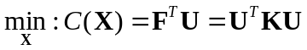 (1)
subject to : 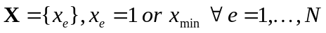 (2)
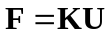 (3)
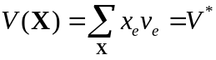 (4)
where the compliance C is the objective function; X is the vector of the elemental relative densities and thus vector of binary design variables as in a common discrete problem; x_{e} is the eth design variable with candidate values of either 1 for solid element (presence) or prescribed x_{min} (0.001 in this paper) for void element (absence); N is the total number of elements; F and U are the global force vector and displacement vector respectively; K is the global stiffness matrix; V is the total volume of the structure with v_{e} being the elemental volume; V* is the imposed value of the volume constraint. Besides the volume constraint in Eq. (4), the constraint defined in Eq. (3) ensures the equilibrium of the structure.
2.2 Optimization algorithms
The BESO method is employed in the Python code to solve the above optimization problem. As a gradient-based method, the design variable update is based on the element sensitivity α_{e} obtained by differentiating the objective function C.
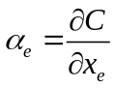 (5)
Detailed calculation of the above differentiation under linear elasticity can be performed based on the SIMP material model (Bendsøe and Sigmund 2003; Huang and Xie 2009) which yields
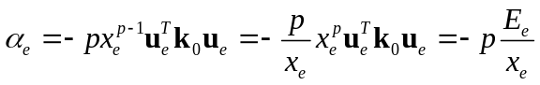 (6)
where p is the penalty exponent (Bendsøe and Sigmund 2003) and has a constant value of 3 in this paper, u_{e} is the elemental displacement vector and k₀ is the element stiffness matrix in a solid status (i.e. x_{e} = 1). It is noted that the sensitivity contains a term x^{p}u_{e}^{T}k₀u_{e} which is exactly the element strain energy E_{e} that can be directly obtained from FEA. The relevant Python implementation of the sensitivity is defined in the function FEA.
This raw sensitivity is usually processed in order to produce a mesh-independent solution (Sigmund and Peterson 1998). A blurring filter can be used for this purpose such as the filter scheme in (Huang and Xie 2007a). Without losing the solution accuracy, a simplified elemental sensitivity filtering scheme is used in this paper as follows.
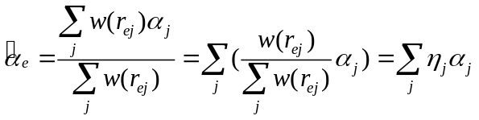 (7)
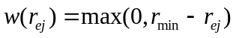 (8)
where r_{ej} is the distance between the centres of elements e and j; w is a weight function for averaging the raw sensitivities; r_{min} is the filter radius. It is noted that the weight factor η_{j} is independent of the sensitivity values and can be calculated beforehand. The Python implementation of this filter scheme is divided into two functions: preFilt that calculates only once and saves the fixed weight factors, and fltAe that applies the filter in each iteration.
In order to achieve a convergent solution, it is recommended to further average the sensitivity with its historical information for discrete methods such as BESO (Huang and Xie 2007a). This is realized by simply averaging the sensitivity of the current iteration with that of the previous iteration.
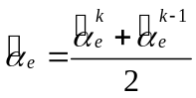 (9)
where k is the current iteration number. In the Python code, this is easily implemented with a one-line expression in the main program.
BESO usually starts from a full design and reduces the structural volume iteratively by switching element status. In the iteration, the target volume of next iteration V^{k+1} is determined based on the current volume V^{k} and an Evolutionary Ratio ert.
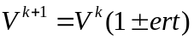 (10)
Then the element update is based on the optimality criteria for soft-kill BESO (Huang and Xie 2010a) that the sensitivities of solid elements (x_{e} = 1) are always lower than those of void elements (x_{e} = x_{min}), for a minimization problem. The update scheme is then devised according to the target volume and the sensitivities: a threshold th shall be determined so that elements with a sensitivity lower than the threshold are switched to solid (if void) and elements with a sensitivity higher than the threshold are switched to void (if solid), the result of which achieves the target volume. The threshold can be determined using a simple bisection method that changes the threshold progressively as shown in Fig. 1. In the Python code, this update algorithm is defined in the function BESO.
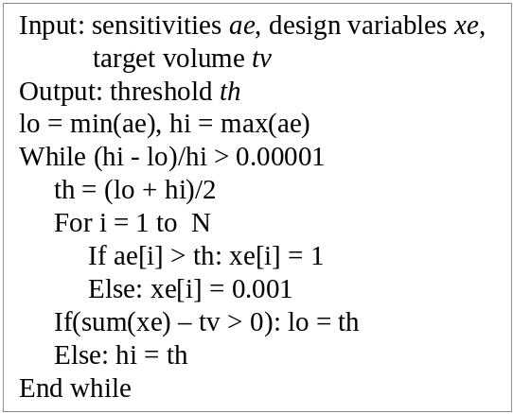
Fig. 1 Pseudocode of the bisection algorithm used in BESO for finding the sensitivity threshold.
3 Python implementation
This section explains the basic form of the Python code which is given in Appendix 1 in full. The code is to be called in Abaqus/CAE through the menu command File->Run Script.
The Python code makes no assumption on the geometry of the design domain. The design domain and required parameters are transferred to the program as input arguments through two prompt dialogues: the first dialogue allows the user to input the predefined parameters for the target final volume fraction, the filter radius and the evolutionary volume ratio; the second dialogue lets the user to specify a model database file (.cae) that contains the model of the design domain (also as the initial structure) of an arbitrary geometry. Fig. 2 shows a 3D cantilever as an example with a filter radius of 4 and target volume fraction of 10%. Note that the input model database shall be prepared such that it contains a model named 'Model-1' with a dependent part named 'Part-1' and a static analysis step named 'Step-1'.
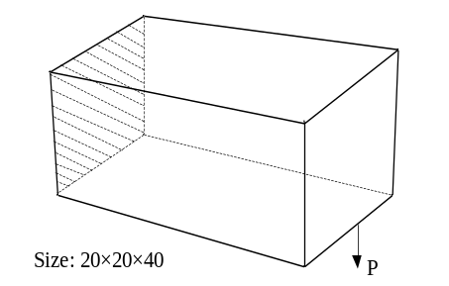
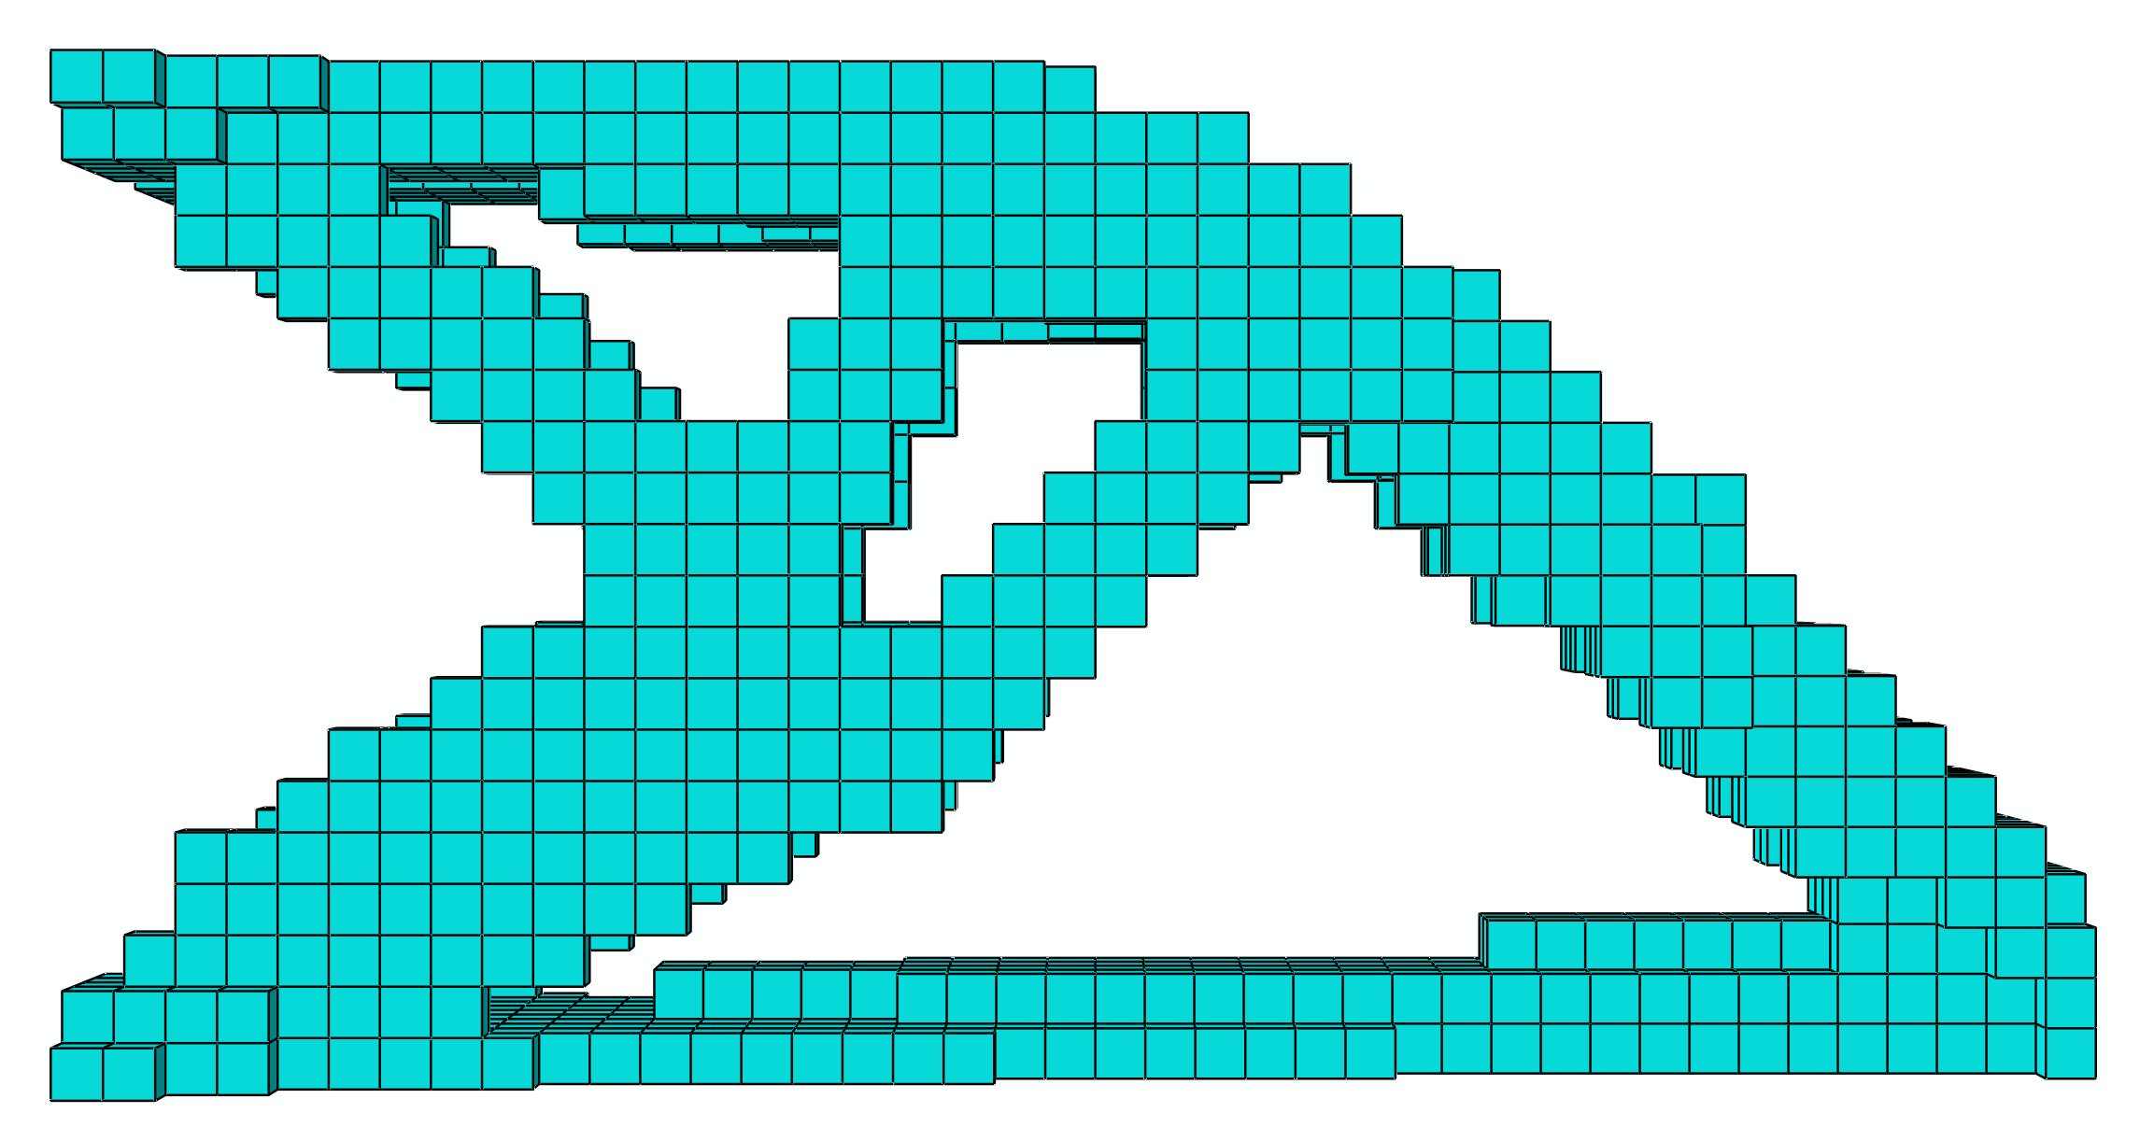
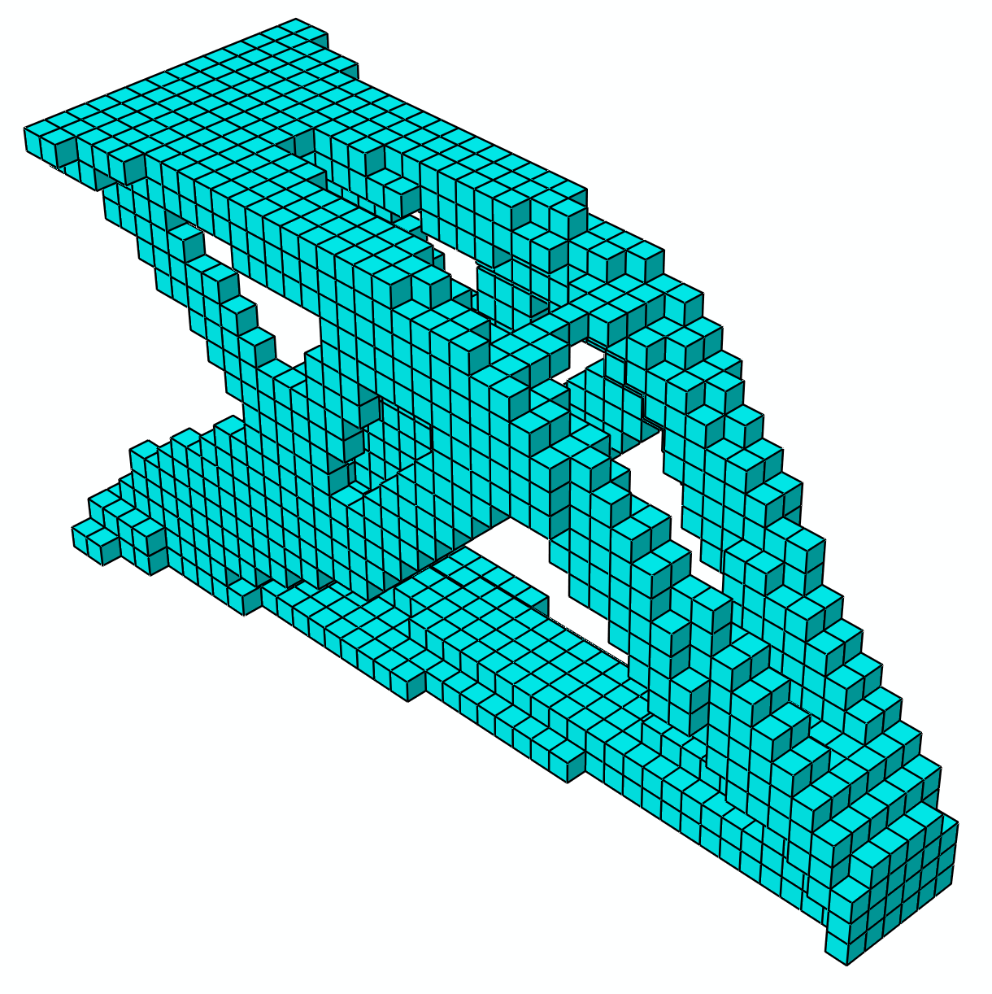
Fig. 2 Topology optimization of a 3D cantilever: (Top) the initial full design as the design domain; (middle and bottom) side and perspective views of the optimized solution.
3.1 Header (lines 2–4)
As a common programming practice, a header exists at the beginning of the script to import a number of modules and functions: the module math is imported for arithmetic functions such as sqrt and fabs (line 2); customKernel (line 2) is an Abaqus extended Python module for storing custom data in a model database; getInput and getInputs (line 3) are two functions imported from the Abaqus module for parsing the input parameters; and openOdb (line 4) is a function imported from the odbAccess module for accessing the FEA results in an Abaqus output database. The modules Abaqus and odbAccess are two common modules for most Python scripts employing ASI and are standard components of the Abaqus software.
3.2 Main program (lines 68–100)
The main program defines the global execution flow. The main program locates at the end of the source code since the Python interpreter needs the definition of all other functions before they are called in the main program.
In the conventional Python programming fashion, the main program starts with such a line as “if __name__ == '__main__':”. In the current main program, this line is followed by the function body that can be partitioned into four blocks: input acquisition, design initialization, iteration loop and result saving. In the input acquisition block, the multiple parameters are obtained (line 72) through the getInputs function and a preliminary verification is done (line 73) to prevent infeasible inputs such as negative final volume. A model database object is created referring to the input design model database and assigned to a variable mddb (line 74) using openMdb with the specified file name that is parsed by the getInput function. A model database object can contain several model objects, each of which further contains a series of member objects such as parts, materials and loads etc. A simplified Abaqus object model hierarchy is shown in Fig. 3 for the model database (mdb); an object model for the output database (odb) is also shown that will be employed later in function FEA.
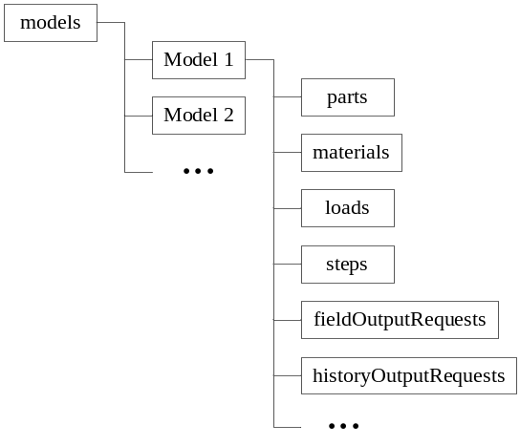  mdb object model | 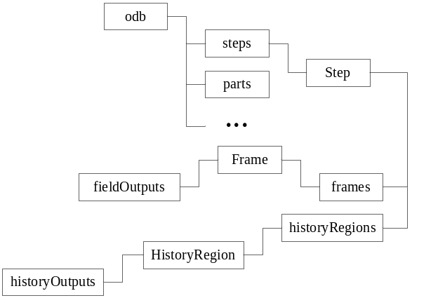  odb object model
Fig. 3 Abaqus object model hierarchy for (left) model database - mdb; (right) output database - odb.
In the design initialization block, the initial design model base is first formatted (line 76) using a function fmtMdb that will be introduced in the following. Since the information in the design part, such as the elemental information, is frequently used in the program, three variables are defined referring to the objects: “Part-1” (part), the elements (elmts) and nodes (nds) in this part for programming simplicity. Two lists (Python data type) are defined to store the historical information for the objective function (oh) and volume fraction (vh) that will be used in verifying the solution convergence as well as in result presentation. Other initialized variables include the dictionaries (Python data type): the design variables (xe), the current element sensitivities (ae), the element sensitivities of an immediately previous iteration (oae) and the element mapping for the filter scheme (fm). Note that both list and dictionary are basic Python data types that store a series of individual objects or numbers. The function preFlt is called (line 82) to prepare the filter scheme if a valid filter radius r_{min} is present; note that r_{min} = 0 will not trigger the filter scheme.
The iteration loop block is entry controlled by checking the convergence error change of the objective function (line 85). A counter iter is used to count the current number of iteration. In the body of the loop, first an FEA is executed (line 88) to obtain the objective function and element sensitivities ae; then ae are filtered (line 90, if a valid r_{min} is present) and history-averaged (line 91); note that the current sensitivities are immediately stored to oae for performing next history-averaging; then the BESO update (line 96) is executed based on ae and the current target volume fraction nv that is determined (line 95) according to Eq. 10; finally, a convergence check (line 97) is performed by evaluating the convergence error change for the entry condition of the next iteration.
In the result saving block, the historical information lists oh and vh are stored to customData (line 99) that is saved into the final design model database (line 100) named “Final_design.cae”. The geometric and historical results can be manually inspected by opening this final data base in Abaqus/CAE, or can be viewed using a separate code that is introduced later in the paper.
3.3 Model formatting: fmtMdb (lines 5–17)
This function formats the initial model database for the soft-kill scheme. The whole model “Model-1” is stored in an Abaqus model object mdl. In the soft-kill scheme, the void elements are interpreted as a very soft material. Therefore two materials are defined by setting up the Young’s moduli and Poisson’s ratios; then these materials are linked to two sections of the design, i.e. solid section (solidSec) and void section (voidSec) respectively (lines 10–13). According to the SIMP model (Bendsøe and Sigmund 2003), the Young’s modulus of the soft material is set to 0.001×10³ (line 12) based on x_{min} = 0.001 and p = 3. Then the solid section is assigned to an element set containing all the elements (line 14) as the BESO procedure will start with the initial full design. In the end, FEA outputs are requested for the element strain energies (line 16) using the Abaqus keyword “ELEDEN”, and for the external work (line 17) using the keyword “ALLWK” that is equivalent to the objective function (compliance) considering no energy dissipation.
3.4 Finite element analysis: FEA (lines 18–27)
This function runs the finite element analysis in the iteration and outputs the element sensitivities Ae in the argument list and the compliance as the function return value. The program submits the analysis job to Abaqus (line 20) and waits till the analysis is finished (line 21). An output database (.odb) is automatically produced by Abaqus after the analysis and is opened by the program (line 22). The element elastic strain energies are retrieved (line 23) according to the odb object model in Fig. 3 and using the Abaqus keyword “ESEDEN”. Then the element sensitivities are obtained by modifying the element strain energies (line 24) according to Eq. 6. Note that for the computational simplicity Ae is not multiplied with the penalty exponent p in the implementation since this will not affect the optimization solution (Huang and Xie 2009). Finally the objective function compliance is retrieved (line 25) using the keyword “ALLWK” and returned by the function.
3.5 Mesh-independent filtering: preFlt (lines 28–44) and fltAe (lines 45–50)
The function preFlt prepares the filter scheme and is called only once in the program to save the computational cost. For each element e, this function finds out the surrounding elements j within the sphere centred at the centroid of the element e with the radius r_{min}; and then calculates the weight factor η_{j} according to Eqs. (7) and (8). For each element e, the labels of elements j and the weight factor η_{j} are stored as lists; these two lists map with the label of element e and form a pair in a dictionary that contains all such pairs over the design domain. This dictionary is saved and later used by fltAe in the iteration. In the implementation, the centre coordinates of each element is first calculated and stored in a dictionary c0 (lines 31–34); then in a double-loop, each over all the elements, the distances between element centres and the relevant weight factors are calculated and stored in the mapping dictionary Fm (lines 36–44).
The function fltAe applies the filter scheme to the element sensitivities according to Eq. (7). In a loop over all elements, the modified sensitivities are obtained (lines 48–50) by multiplying η_{j} with the raw sensitivities (line 47) based on the filter mapping dictionary Fm.
3.6 Element updating: BESO (lines 51–67)
This function implements the BESO optimizer and is the core of the Python code. This function first determines the sensitivity threshold th (lines 53–59) following the bisection algorithm shown in Fig. 1; during this procedure the design variables Xe are also set by assigning 1.0 to solid elements and 0.001 to void elements. According to the design variables, the labels of all elements are grouped into two lists: slb for solid elements and vlb for void elements (lines 61–64). Then the solid and void sections are assigned to the two element sets that are created using the lists slb and vlb respectively (lines 66–67).
It should be noted that the above BESO optimizer can be replaced by another 0-1 optimizer for test and comparison purposes. The replacement can be conveniently done, with lines 60–67 remaining in the current form.
4 Extensions to practical applications
This Python code is well-structured and sets up a framework for general topology optimization using BESO. Therefore, it can be easily altered to achieve other objectives with only limited modifications to the current form. A few modifications are introduced in the following as examples.
4.1 Increasing computational efficiency
The basic arithmetic functions of the Python language are not optimized and may therefore lead to poor performance when a large amount of computation is involved. A few separate Python libraries such as NumPy (www.numpy.org) and SciPy (www.scipy.org) optimized for scientific computation have been developed and widely used by the Python community.
The current Python code in its basic form performs well on small FE models such as a 2D model; however when dealing with large 3D models with a large number of elements, a bottleneck may occur in preFlt due to the large amount of arithmetic calculations in the loops. In this case, the NumPy library can be employed to significantly improve the computation speed. Note that NumPy is neither a standard component of the Python language nor included in the original Abaqus distribution; therefore the reader needs to additionally install the NumPy package (freely downloadable from www.numpy.org) for the Python version used in his/her Abaqus software. It is for this reason that the implementation involving NumPy is presented as an extension rather than in the basic code.
In this extension, the affected code is only in preFlt; Appendix 2 gives the full source code of this modified function with which the user can easily replace the basic version. NumPy is first imported and renamed as np for programming simplicity. Several NumPy functions are used to replace the fundamental versions, such as np.add replaces +, np.subtract replaces -, np.divide replaces /, np.square replaces sqrt, and np.power replaces pow; besides, np.zero is used to initialise a list with all zero entries and np.sum is used to get the summation of all entries inside a list.
NumPy can also be implemented in other functions of the Python code; the authors decide to leave this to interested readers as a programming practice.
4.2 Multiple load cases
Multiple load cases can be easily addressed by extending the basic Python code, given that the input model defines multiple load cases. For convenient reading of FEA results, the multiple analysis steps can be defined in the input model and each step corresponds to one load case. This extension requires modifications on the functions fmtMdb and FEA.
For fmtMdb, the modification takes place for the block of defining output requests. The program loops through all analysis steps requesting element energy densities and external work. This is realized by replacing lines 16 and 17 by the following loop.
016 for stp in [k for k in mdl.steps.keys() if k != 'Initial']:
mdl.FieldOutputRequest('SEDensity'+stp,stp,variables=('ELEDEN', ))
mdl.HistoryOutputRequest('ExtWork'+stp,stp,variables=('ALLWK', ))
Accordingly for FEA, the modification takes place for the block of reading the analysis outputs. Using a loop, the element sensitivities and the objective function are summed up over all analysis steps; in other words, the weight factors for all steps are identical and the objective function is defined as follows.
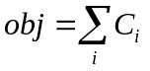 (11)
where C_{i} is the compliance of the ith load case. The Python implementation is realized by replacing lines 23-25 with the following block.
023 obj = 0
for k in Xe.keys(): Ae[k] = 0.0
for stp in opdb.steps.values():
seng = stp.frames[-1].fieldOutputs['ESEDEN'].values
for en in seng: Ae[en.elementLabel]+=en.data/Xe[en.elementLabel]
obj += stp.historyRegions['Assembly ASSEMBLY'].historyOutputs['ALLWK'].data[-1][1]
An example is given in Fig. 4 where the 3D cantilever has the identical geometry as that in Fig. 2 but includes an additional load case. A filter radius of 4 and target final volume fraction of 10% are used in this example.
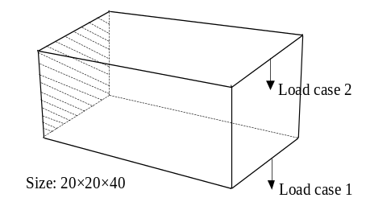
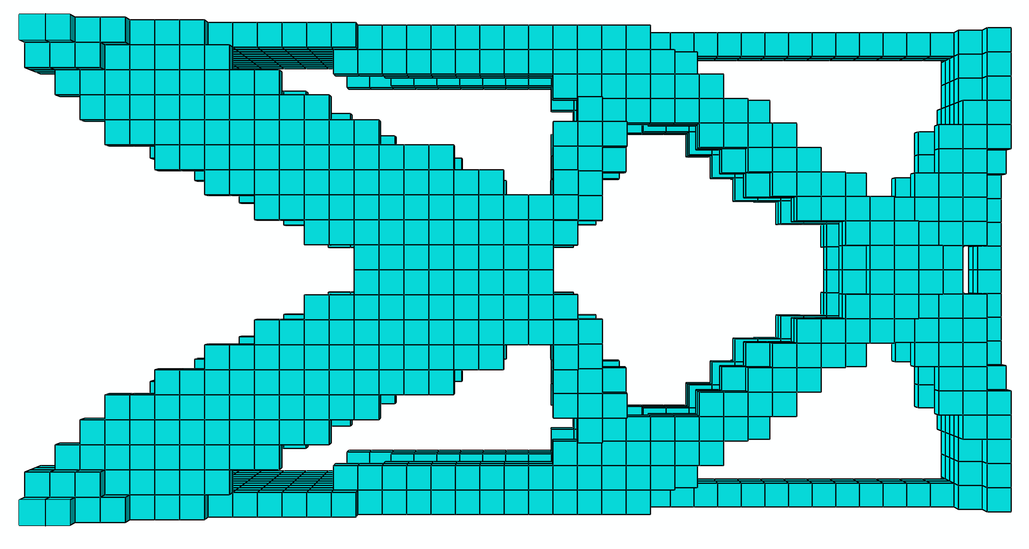
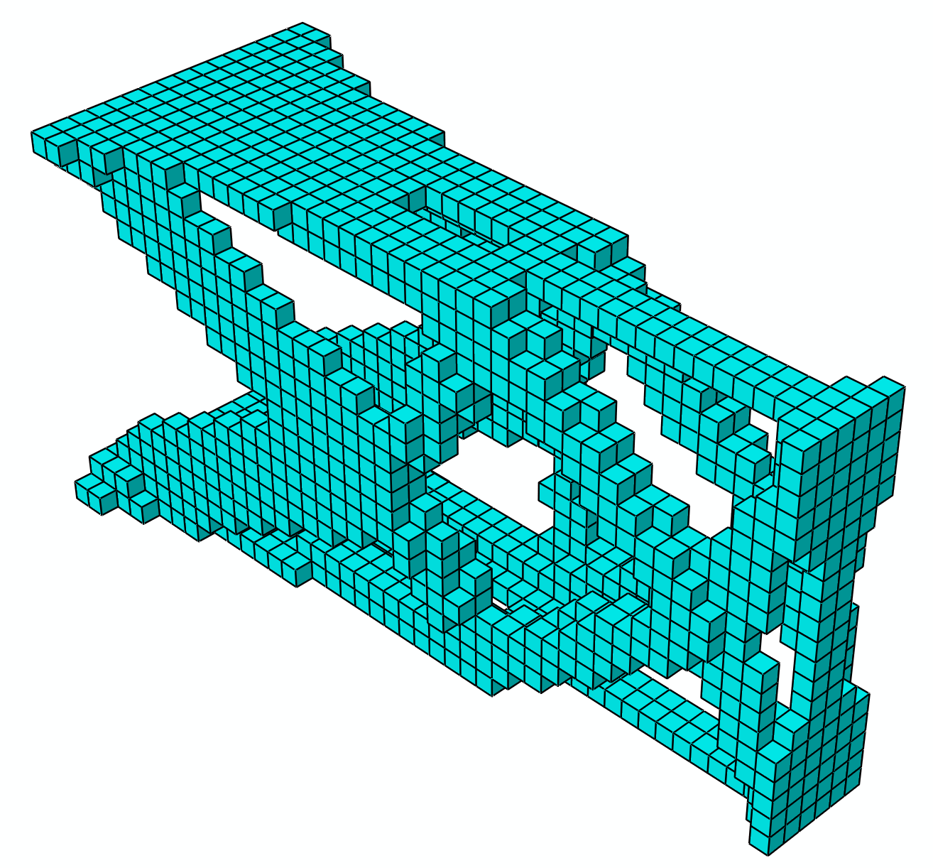
Fig. 4 Topology optimization of a 3D cantilever with two load cases: (Top) the initial full design as the design domain; (middle and bottom) side and perspective views of the optimized solution.
4.3 Geometric restrictions
Geometric restrictions such as a design domain of specific shape and non-designable areas can be readily taken into account by the proposed Python implementation. Using the graphical interface Abaqus/CAE, arbitrary shaped geometries can be created and then directly taken as the design domain. It is noted that the previous Matlab implementations (e.g. Sigmund 2001; Huang and Xie 2010a; Andreassen et al. 2011; Liu and Tovar 2014) are based on regular design domains of 2D square or 3D cube shapes with the concept of “passive elements” to create initial cavities, which is indirectly realized by changing the source codes.
Additionally, non-designable areas are solid and allow no cavities to be created inside. Since the current Python code takes only the part “Part-1” in model “Model-1” in the model database as the design domain, any other parts are automatically regarded non-designable. Therefore, a non-designable domain can be easily realized by defining an addition part besides “Part-1”.
Fig. 5 shows an example with both initial voids and a non-designable layer. Due to symmetry, only one quarter of the full structure is considered in Abaqus/CAE. The designable “Part-1” in green colour is attached to the non-designable “Part-2” in white colour using a tie-constraint. Two voids are cut off at the bottom of “Part-1” to create an extrusive pier that is fixed at the base. A uniform pressure is applied on the top surface of “Part-2”. A filter radius of 4 times the element size and a target final volume fraction of 20% are used in this example.
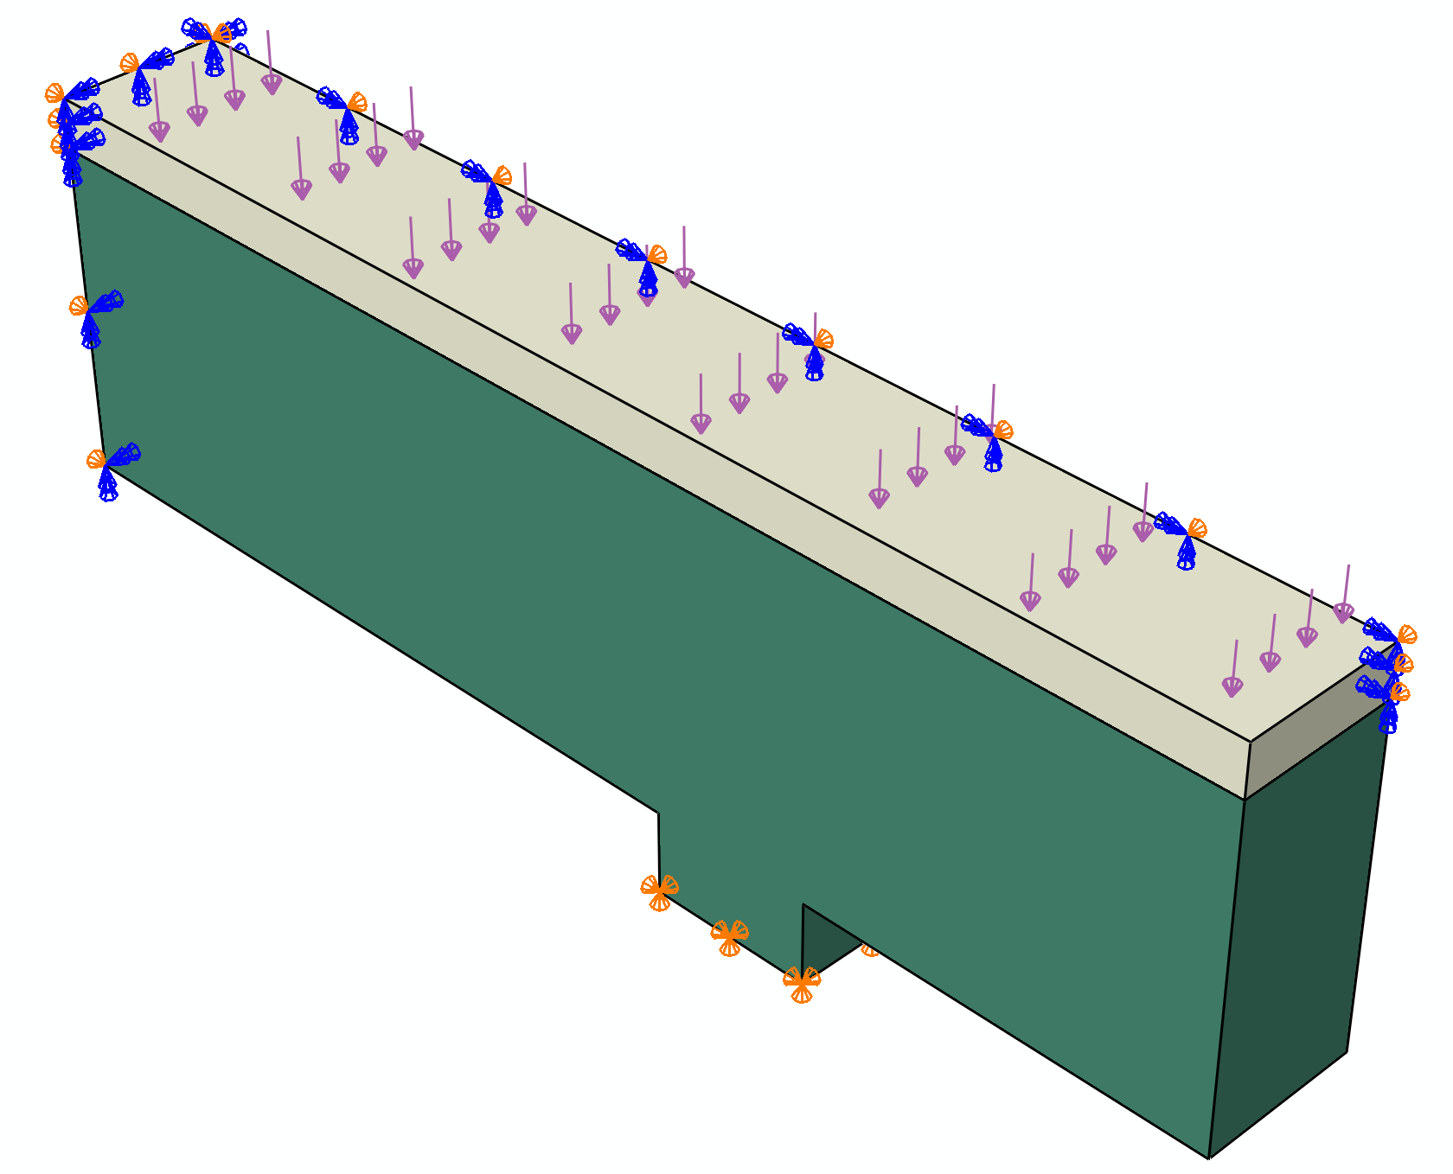
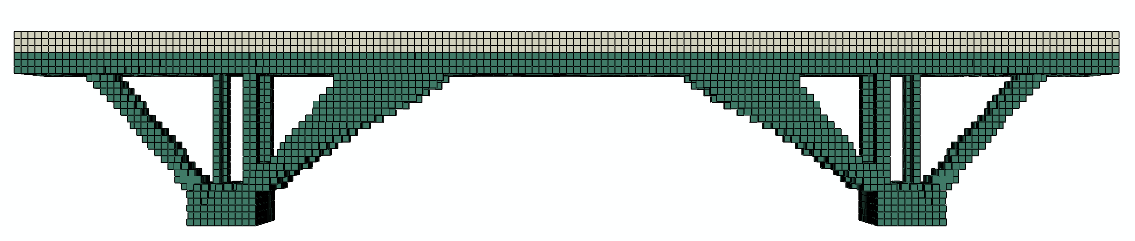
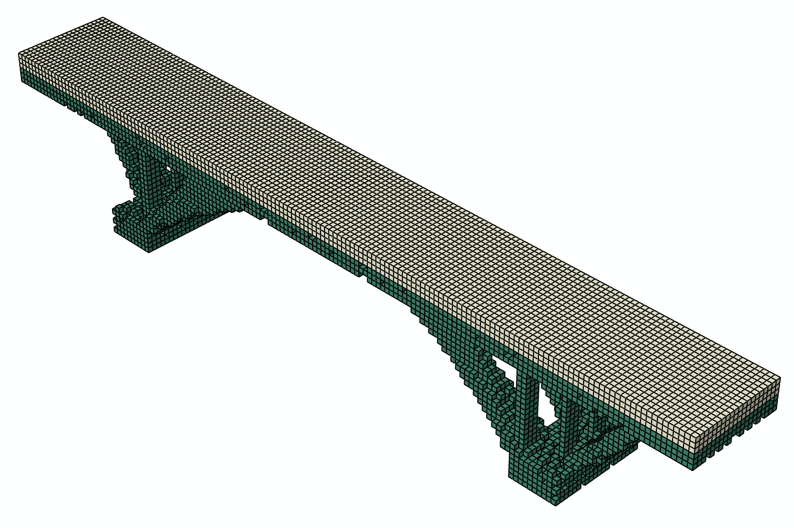
Fig. 5 Topology optimization with initial voids and a non-designable part: (Top) the design domain (one quarter model); (middle and bottom) side and perspective views of the optimized solution of the full bridge.
Fig. 6 shows an example of a gear design with a circular shaped design domain and non-designable inner- and outer-rings; the designable “Part-1” in green colour is attached to the non-designable “Part-2” in white colour using a tie-constraint. Three load cases are applied as surface tractions, each being two concentrated forces of 100 N on the outer-ring. The inner ring is fixed on the internal surface. A filter radius of 2 and a target final volume fraction of 20% are used.
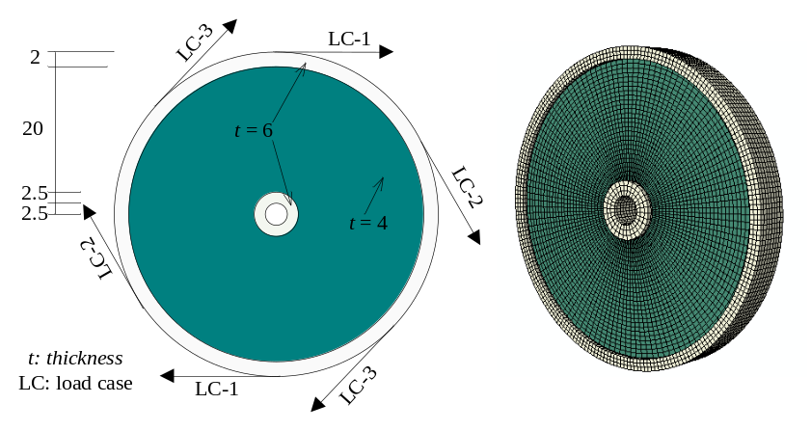
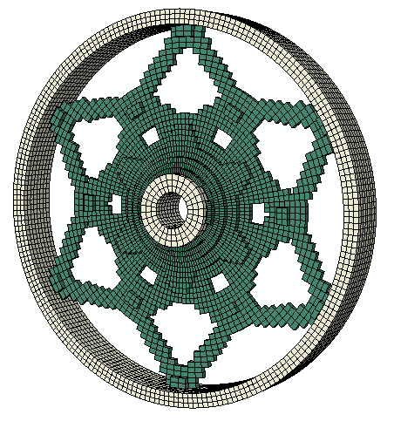
Fig. 6 Topology optimization with geometric restrictions: (Top) the design domain and boundary conditions; (bottom) a perspective view of the optimized solution of the gear.
4.4 Optimization considering nonlinearities
According to literature (Buhl et al. 2000; Huang and Xie 2007b), the element sensitivity of nonlinear compliance minimization can be obtained as the sum of the total elastic strain energy E^{e} and plastic strain energy E^{p} in the element as follows.
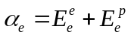 (12)
According to the above sensitivity calculation, the compliance minimization with both material and geometrical nonlinearities can be realized by simply requesting the total elemental energy densities (modify fmtMdb using Abaqus keyword “ENER”) and reading from odb the elastic and plastic strain energies (modify FEA using keywords “SENER” and “PENER” respectively).
More simply, geometrical nonlinearity is readily activated without any change to the code, as long as a standard static analysis step in the input model is defined with the option of geometrical nonlinearity using Abaqus/CAE. Nevertheless, a nonlinear analysis may not be able to converge due to reasons such as inappropriate load increments. In order to protect the optimization procedure from such unexpected errors, the Python exception handling mechanism may be implemented in the function FEA by replacing lines 20 and 21 with the following block.
020 try:
Mdb.Job('Design_Job'+str(Iter),'Model-1').submit()
Mdb.jobs['Design_Job'+str(Iter)].waitForCompletion()
except AbaqusException, message:
print "Error occured: ", message
sys.exit(1)
Fig. 7 shows the topology optimization of a double-clamped beam with a filter radius of 2 and a final target volume fraction of 30% of the design domain. Both a linear solution and a geometrically nonlinear solution are presented for comparison. These results are similar to those in the literature (e.g. Huang and Xie 2007b).

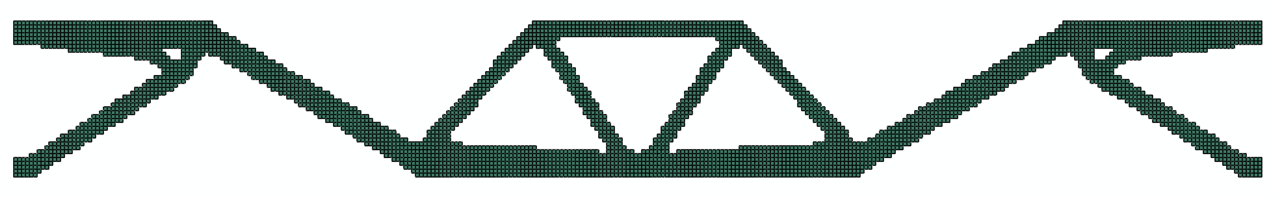
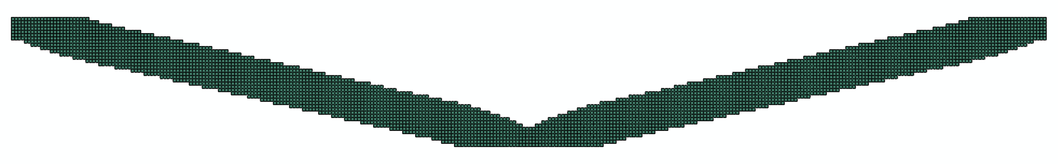
Fig. 7 Topology optimization of a double clamped beam: (Top) the initial full design as the design domain; (middle) linear solution; (bottom) geometrically nonlinear solution.
4.5 Result presentation
This is a separate Python code that is written for automatic result presentation. It consists of three blocks: plotting the historical information of the volume fraction, plotting the historical information of the objective function, and displaying the final geometry. The complete code is presented in Appendix 3. Although this extension is useful to some researchers and students, it is not directly related to topology optimization. Therefore the authors decide not to explain this part of the source code in detail.
5 Conclusions
This paper presents a simple Python code for topology optimization of general 2D and 3D structures. The compact 100-lined code is developed for the compliance minimization with a volume constraint. With simple modifications, the basic Python code has been extended to enhance computational efficiency and to consider multiple load cases and nonlinearities. More importantly, the code provides a convenient platform upon which further extensions such as new functions and different optimizers could be easily built. In doing so, the user may experiment with various algorithms and tackle a wide range of problems. The Python code is presented primarily for educational purposes. Nevertheless, with extensions such as those presented in this paper and with the Abaqus FEA/modelling power, the Python code is capable of solving practical topology optimization problems and of generating complex conceptual designs. The complete codes are given in the appendix section for users to copy and save as .py files to run with Abaqus/CAE. These codes may also be downloaded from the website: www.rmit.edu.au/research/cism/.

References
Andreassen E, Clausen A, Schevenels M, Lazarov BS, Sigmund O (2011) Efficient topology optimization in Matlab using 88 lines of code. Struct Multidisc Optim 43(1):1–16
Bendsøe MP (1989) Optimal shape design as a material distribution problem. Struct Optim 1:193–202
Bendsøe MP, Sigmund O (2003) Topology Optimization: Theory, Methods and Applications, Berlin, Springer-Verlag
Buhl T, Pedersen CBW, Sigmund O (2000) Stiffness design of geometrically nonlinear structures using topology optimization. Struct Multidisc Optim 19:93–104
Challis VJ (2010) A discrete level-set topology optimization code written in Matlab. Struct Multidisc Optim 41:453–464
Dassault Systemes (2014) http://www.3ds.com/products-services/simulia/portfolio/abaqus/overview/
Huang X, Xie YM (2007a) Convergent and mesh-independent solutions for the bi-directional evolutionary structural optimization method. Finite Elem Anal Des 43:1039–1049
Huang X, Xie YM (2007b) Bidirectional evolutionary topology optimization for structures with geometrical and material nonlinearities. AIAA J 45(1):308-313
Huang X, Xie YM (2009) Bi-directional evolutionary topology optimization of continuum structures with one or multiple materials. Comput Mech 43:393–401
Huang X, Xie YM (2010a) A further review of ESO type methods for topology optimization. Struct Multidisc Optim 41:671–683
Huang X, Xie YM (2010b) Evolutionary Topology Optimization of Continuum Structures: Methods and Applications, Chichester, John Wiley & Sons
Huang X, Xie YM (2010c) Evolutionary topology optimization of continuum structures with an additional displacement constraint. Struct Multidisc Optim 40:409-416
Huang X, Zhou SW, Xie YM, Li Q (2013) Topology optimization of microstructures of cellular materials and composites for macrostructures. Comput Mater Sci 67:397-407
Huang X, Zuo ZH, Xie YM (2010) Evolutionary topological optimization of vibrating continuum structures for natural frequencies. Comput Struct 88:357-364
Liu K, Tovar A (2014) An efficient 3D topology optimization code written in Matlab. Struct Multidisc Optim (online) DOI 10.1007/s00158-014-1107-x
Osher SJ, Sethian JA (1988) Fronts propagating with curvature dependent speed: algorithms based on the Hamilton–Jacobi formulation. J Comput Phys 79:12–49
Radman A, Huang X, Xie YM (2014) Maximizing stiffness of functionally graded materials with prescribed variation of thermal conductivity, Comput Mater Sci 82:457-463
Sigmund O (1995) Tailoring materials with prescribed elastic properties. Mech Mater 20:351-368
Sigmund O (2001) A 99 line topology optimization code written in Matlab. Struct Multidisc Optim 21:120–127
Sigmund O, Peterson J (1998) Numerical instabilities in topology optimization: a survey on procedures dealing with checkerboards, mesh-dependencies and local minima. Struct Optim 16:68–75
Wang MY, Wang X, Guo D (2003) A level set method for structural topology optimization. Comput Methods Appl Mech Eng 192:227–246
Xie YM, Steven GP (1993) A simple evolutionary procedure for structural optimization. Comput Struct 49(5):885-896
Xie YM and Steven GP (1997) Evolutionary Structural Optimization, London, Springer
Yang XY, Huang X, Rong JH, Xie YM (2013) Design of 3D orthotropic materials with prescribed ratios for effective Young’s moduli. Comput Mater Sci 67:229-237
Zhou M, Rozvany GIN (1991) The COC algorithm, part II: Topological, geometry and generalized shape optimization. Comp Methods Appl Mech Eng 89: 197–224
Zuo ZH, Huang X, Rong JH, Xie YM (2013) Multi-scale design of composite materials and structures for maximum natural frequencies. Mater Des 51:1023-1034
Zuo ZH, Xie YM, Huang X (2012) Evolutionary topology optimization of structures with multiple displacement and frequency constraints. Adv Struct Eng 15(2):385-398

Appendix 1: Basic Python code
001 """General 3D topology optimization code based on BESO by Zhi Hao Zuo and Yi Min Xie. Note that the CAE file shall contain a model 'Model-1' with a dependent part 'Part-1' and a static step 'Step-1'."""
002 import math,customKernel
003 from abaqus import getInput,getInputs
004 from odbAccess import openOdb
005 ## Function of formatting Abaqus model for stiffness optimization
006 def fmtMdb(Mdb):
007 mdl = Mdb.models['Model-1']
008 part = mdl.parts['Part-1']
009 # Build sections and assign solid section
010 mdl.Material('Material01').Elastic(((1.0, 0.3), ))
011 mdl.HomogeneousSolidSection('sldSec','Material01')
012 mdl.Material('Material02').Elastic(((0.001**3, 0.3), ))
013 mdl.HomogeneousSolidSection('voidSec','Material02')
014 part.SectionAssignment(part.Set('ss',part.elements),'sldSec')
015 # Define output request
016 mdl.FieldOutputRequest('SEDensity','Step-1',variables=('ELEDEN', ))
017 mdl.HistoryOutputRequest('ExtWork','Step-1',variables=('ALLWK', ))
018 ## Function of running FEA for raw sensitivities and objective function
019 def FEA(Iter,Mdb,Xe,Ae):
020 Mdb.Job('Design_Job'+str(Iter),'Model-1').submit()
021 Mdb.jobs['Design_Job'+str(Iter)].waitForCompletion()
022 opdb = openOdb('Design_Job'+str(Iter)+'.odb')
023 seng = opdb.steps['Step-1'].frames[-1].fieldOutputs['ESEDEN'].values
024 for en in seng: Ae[en.elementLabel]=en.data/Xe[en.elementLabel]
025 obj=opdb.steps['Step-1'].historyRegions['Assembly ASSEMBLY'].historyOutputs['ALLWK'].data[-1][1]
026 opdb.close()
027 return obj
028 ## Function of preparing filter map (Fm={elm1:[[el1,el2,...],[wf1,wf2,...]],...})
029 def preFlt(Rmin,Elmts,Nds,Fm):
030 # Calculate element centre coordinates
031 c0 = {}
032 for el in Elmts:
033 nds = el.connectivity
034 c0[el.label]=[sum([Nds[nd].coordinates[i]/len(nds) for nd in nds]) for i in range(3)]
035 # Weighting factors
036 for el in Elmts:
037 Fm[el.label] = [[],[]]
038 for em in Elmts:
039 dis=math.sqrt(sum([(c0[el.label][i]-c0[em.label][i])**2 for i in range(3)]))
040 if dis<Rmin:
041 Fm[el.label][0].append(em.label)
042 Fm[el.label][1].append(Rmin - dis)
043 sm = sum(Fm[el.label][1])
044 for i in range(len(Fm[el.label][0])): Fm[el.label][1][i] /= sm
045 ## Function of filtering sensitivities
046 def fltAe(Ae,Fm):
047 raw = Ae.copy()
048 for el in Fm.keys():
049 Ae[el] = 0.0
050 for i in range(len(Fm[el][0])): Ae[el]+=raw[Fm[el][0][i]]*Fm[el][1][i]
051 ## Function of optimality update for design variables and Abaqus model
052 def BESO(Vf,Xe,Ae,Part,Elmts):
053 lo, hi = min(Ae.values()), max(Ae.values())
054 tv = Vf*len(Elmts)
055 while (hi-lo)/hi > 1.0e-5:
056 th = (lo+hi)/2.0
057 for key in Xe.keys(): Xe[key] = 1.0 if Ae[key]>th else 0.001
058 if sum(Xe.values())-tv>0: lo = th
059 else: hi = th
060 # Label elements as solid or void
061 vlb, slb = [], []
062 for el in Elmts:
063 if Xe[el.label] == 1.0: slb.append(el.label)
064 else: vlb.append(el.label)
065 # Assign solid and void elements to each section
066 Part.SectionAssignment(Part.SetFromElementLabels('ss',slb),'sldSec')
067 Part.SectionAssignment(Part.SetFromElementLabels('vs',vlb),'voidSec')
068 ## ====== MAIN PROGRAM ======
069 if __name__ == '__main__':
070 # Set parameters and inputs
071 pars = (('VolFrac:','0.5'), ('Rmin:', '1'), ('ER:', '0.02'))
072 vf,rmin,ert = [float(k) if k!=None else 0 for k in getInputs(pars,dialogTitle='Parameters')]
073 if vf<=0 or rmin<0 or ert<=0: sys.exit()
074 mddb = openMdb(getInput('Input CAE file:',default='Test.cae'))
075 # Design initialization
075 fmtMdb(mddb)
077 part = mddb.models['Model-1'].parts['Part-1']
078 elmts, nds = part.elements, part.nodes
079 oh, vh = [], []
080 xe, ae, oae, fm = {}, {}, {}, {}
081 for el in elmts: xe[el.label] = 1.0
082 if rmin>0: preFlt(rmin,elmts,nds,fm)
083 # Optimization iteration
084 change, iter, obj = 1, -1, 0
085 while change > 0.001:
086 iter += 1
087 # Run FEA
088 oh.append(FEA(iter,mddb,xe,ae))
089 # Process sensitivities
090 if rmin>0: fltAe(ae,fm)
091 if iter > 0: ae=dict([(k,(ae[k]+oae[k])/2.0) for k in ae.keys()])
092 oae = ae.copy()
093 # BESO optimization
094 vh.append(sum(xe.values())/len(xe))
095 nv = max(vf,vh[-1]*(1.0-ert))
096 BESO(nv,xe,ae,part,elmts)
097 if iter>10: change=math.fabs((sum(oh[iter-4:iter+1])-sum(oh[iter-9:iter-4]))/sum(oh[iter-9:iter-4]))
098 # Save results
099 mddb.customData.History = {'vol':vh,'obj':oh}
100 mddb.saveAs('Final_design.cae')

Appendix 2: preFlt implementing NumPy (replaces lines 28-44 in Appendix 1)
028 ## Function of preparing filter map (Fm = {elm1:[[el1,el2,...],[wf1,wf2,...]],...}) (NumPy)
def preFlt(Rmin,Elmts,Nds,Fm):
import numpy as np
# Calculate element centre coordinates
elm, c0 = np.zeros(len(Elmts)), np.zeros((len(Elmts),3))
for i in range(len(elm)):
elm[i] = Elmts[i].label
nds = Elmts[i].connectivity
for nd in nds: c0[i] = np.add(c0[i],np.divide(Nds[nd].coordinates,len(nds)))
# Weighting factors
for i in range(len(elm)):
Fm[elm[i]] = [[],[]]
for j in range(len(elm)):
dis = np.square(np.sum(np.power(np.subtract(c0[i],c0[j]),2)))
if dis<Rmin:
Fm[elm[i]][0].append(elm[j])
Fm[elm[i]][1].append(Rmin - dis)
Fm[elm[i]][1] = np.divide(Fm[elm[i]][1],np.sum(Fm[elm[i]][1]))

Appendix 3: result presentation
001 """This is a complete script used to automatically display results generated by the Python code in this paper."""
002 import customKernel
003 from caeModules import *
004 ## Function of plotting optimization results
005 def pltRslts(mddb):
006 itern = len(mddb.customData.History['obj'])
007 # Plot volume fraction history
008 vp1 = session.Viewport('Volume history',origin=(10,10),width=150,height=100)
009 xyPlot1 = session.XYPlot('Volume fraction')
010 chart1 = xyPlot1.charts.values()[0]
011 volDat = [(k,mddb.customData.History['vol'][k]) for k in range(itern)]
012 xydv = session.XYData('Volume fraction',volDat)
013 chart1.setValues(curvesToPlot=[session.Curve(xydv)])
014 chart1.axes1[0].axisData.setValues(title='Iteration')
015 chart1.axes2[0].axisData.setValues(title='Volume fraction')
016 vp1.setValues(displayedObject=xyPlot1)
017 # Plot objective function history
018 vp2 = session.Viewport('Objective history',origin=(20,20),width=150,height=100)
019 xyPlot2 = session.XYPlot('Objective function')
020 chart2 = xyPlot2.charts.values()[0]
021 objDat = [(k,mddb.customData.History['obj'][k]) for k in range(itern)]
022 xydo = session.XYData('Objective function',objDat)
023 chart2.setValues(curvesToPlot=[session.Curve(xydo)])
024 chart2.axes1[0].axisData.setValues(title='Iteration')
025 chart2.axes2[0].axisData.setValues(title='Objective function')
026 vp2.setValues(displayedObject=xyPlot2)
027 # Display final design
028 vp3 = session.Viewport('Final design', origin=(30,30),width=150, height=100)
029 p = mddb.models['Model-1'].parts['Part-1']
030 vp3.setValues(displayedObject=p)
031 vp3.partDisplay.setValues(mesh=ON)
032 vp3.partDisplay.displayGroup.remove(leaf=dgm.LeafFromSets(sets=(p.sets['vs'],)))
033 ## ====== MAIN PROGRAM ======
034 if __name__ == '__main__':
035 mddb = openMdb(getInput('Input CAE file:',default='Final_Design.cae'))
036 pltRslts(mddb)

